NAME:

CS 583 – Assignment 2

1. We have three random variables, *A*, *B*, *C*, each of which is binary. We have the following factors over these variables: (*A*), (*B*), (*C*), (*A, B*), (*A, C*), (*B, C*).
   1. Draw a Markov network graph over these variables.
   2. Draw a factor graph over these variables.
   3. Here are the values of the factors. Compute *P*(*A*, *B*, *C*).

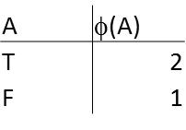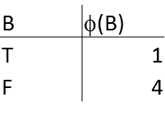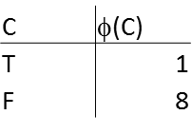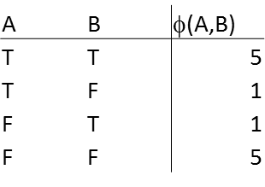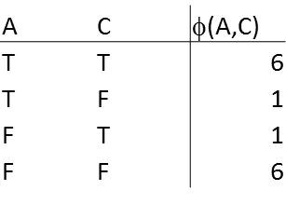

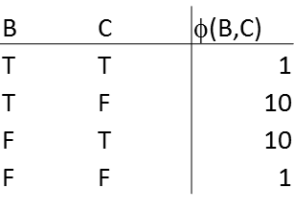

1. For the following Markov network graph, indicate whether the following independence statements are True or False.

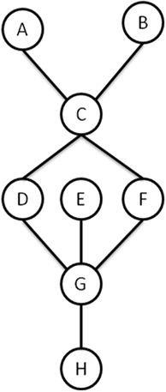

* 1. A  B
  2. A  B | C
  3. A  G | D
  4. A  G | D, F
  5. A  H | G

1. We have the Markov network over 3 binary variables: 𝐴 − 𝐵 − 𝐶. We define a pairwise Markov random field (MRF) over this network. We define the following features.

𝑓1(𝐴) = 1 𝑖𝑓 𝐴 = 𝑇, 0 otherwise. 𝑤1 = ln (2).q

𝑓2(𝐵) = 1 𝑖𝑓 𝐵 = 𝐹, 0 otherwise. 𝑤2 = −ln (3).

𝑓3(𝐶) = 1 𝑖𝑓 𝐶 = 𝑇, 0 otherwise. 𝑤3 = ln (4).

𝑓$(𝐴, 𝐵) = 1 𝑖𝑓 𝐴 = 𝐵, 0 otherwise. 𝑤$ = −ln (5).

𝑓5(𝐵, 𝐶) = 1 𝑖𝑓 𝐵 ≠ 𝐶, 0 otherwise. 𝑤5 = ln (6).

𝑃(

𝐴, 𝐵, 𝐶)

1

= 𝑍 𝑒

5

1$1

& ∑

(i×*i(𝐴,𝐵,𝐶)

Note that to simplify the notation, we simply wrote 𝑓2(𝐴, 𝐵, 𝐶), though features are defined only over nodes and edges. Assume 𝑓2 ignores the variables that it is not defined over. For example, 𝑓1(𝐴, 𝐵, 𝐶) = 𝑓1(𝐴). Populate the following table.

|  |  |  |  |  |
| --- | --- | --- | --- | --- |
| A | B | C | 𝜙(𝐴) ∗ 𝜙(𝐵) ∗ 𝜙(𝐶) ∗ 𝜙(𝐴, 𝐵) ∗ 𝜙(𝐵, 𝐶) = 𝑒! ∑5 w ×ƒ (𝐴,𝐵,𝐶)  1$1 i i | 𝑃(𝐴, 𝐵, 𝐶) |
| T | T | T |  |  |
| T | T | F |  |  |
| T | F | T |  |  |
| T | F | F |  |  |
| F | T | T |  |  |
| F | T | F |  |  |
| F | F | T |  |  |
| F | F | F |  |  |

Hints: 𝑒34 (𝑥) = 𝑥 and 𝑒&34 (𝑥) = 1 = 1

𝑒l& (𝑥)

.

𝑥

1. We have a document classification task. We have four documents, *D*1 and *D*2. We are interested in classifying these documents into one of two topics: Artificial Intelligence (AI) or Databases (DB). Each document has one or both words: Agent and SQL.

We will represent this data as follows: the labels of *D*1 and *D*2 are: *Y*1 and *Y*2. Each *Yi* can take one of two values: AI or DB. The presence of word Agent in document *Di* represented as *X*1i, and the presence of the word SQL in document *Di* represented as *X*2i. The documents and their contents are as follows:

*D*1: *X*11 = True, *X*21 = False (i.e, *D*1 contains only the word Agent)

*D*2: *X*12 = True, *X*22 = True (i.e., *D*2 contains both words)

We also have the additional knowledge that *D*1 cites *D*2. We construct the following CRF, with the following feature functions.

Features:

*f*1(*X*1i, *Y*i) = 1 if X1i = T and Yi = AI, 0 otherwise; *w*1 = -1. *f*2(*X*1i, *Y*i) = 1 if X1i = T and Yi = DB, 0 otherwise; *w*2 = +1. *f*3(*X*2i, *Y*i) = 1 if X2i = T and Yi = AI, 0 otherwise; *w*3 = +1. *f*4(*X*2i, *Y*i) = 1 if X2i = T and Yi = DB, 0 otherwise; *w*4 = -1. *f*5(*Y*i, *Y*j) = 1 if Yi=Yj, 0 otherwise; *w*5 = -1.

*f*6(*Y*i, *Y*j) = 1 if YiYj, 0 otherwise; *w*6 = +1. Potentials:

*1(X*1*i, Yi) = e-(w1f1+ w2f2)*

*2(X*2*i, Yi) = e-(w3f3+ w4f4)*

*3(Yi, Yj) = e-(w5f5+ w6f6)*

The factor graph is given as follows:

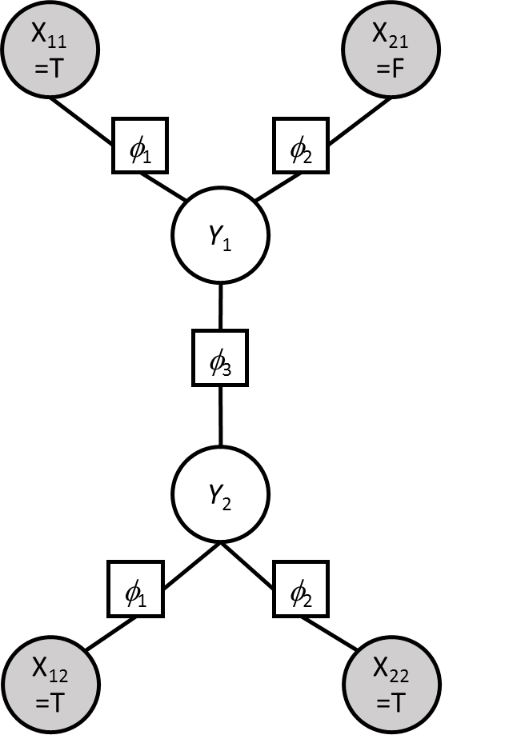

Calculate P(***Y***|***X***), that is P(*Y1*, *Y*2 | *X*11=T, *X*21=F, *X*12=T, *X*22=T). What is the MAP assignment to ***Y*** given ***X***? Show your work.

1. We are given the following Markov network structure, H.

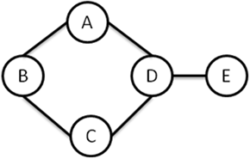

* 1. Find a minimal I-Map Bayesian network structure G1 for H. Use the variable order of A, B, C, D, E.
  2. Find a minimal I-Map Bayesian network structure G2 for H. Use the variable order of E, D, C, B, A.
  3. Is G1 a P-Map for H? If not, which independencies are missing?
  4. Is G2 a P-Map for H? If not, which independencies are missing?

1. We are given the following Bayesian network structure G.

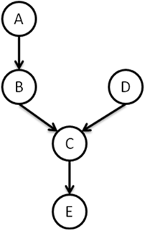

* 1. Find a minimal I-Map Markov network structure H for G. Use any method/variable order you like; make sure H is a *minimal* I-Map.
  2. Is H a P-Map for G? If not, which independencies are missing?